Group activity: Integrating source material into a speech

Rhetorical situation: You and your group have been invited to a symposium on fictional characters who are memorable. Your task is to introduce the audience to a fictional character and explain, using the character’s words and actions, why he/she is memorable and/or worthy of admiration. At the end of the symposium, the audience members will vote on which characters to include in a Fictional Characters Hall of Fame.

Audience analysis: Your audience is made up primarily of scholars and enthusiasts. You can assume that they are highly educated, and that they have respect for the fictional characters who will be discussed. They come from a variety of backgrounds, so you should assume and be sensitive to differences. Most of them will be familiar with the characters who are talking about, but not all of them.

Your topic:
The character your group is working with is
MARY POPPINS from Mary Poppins
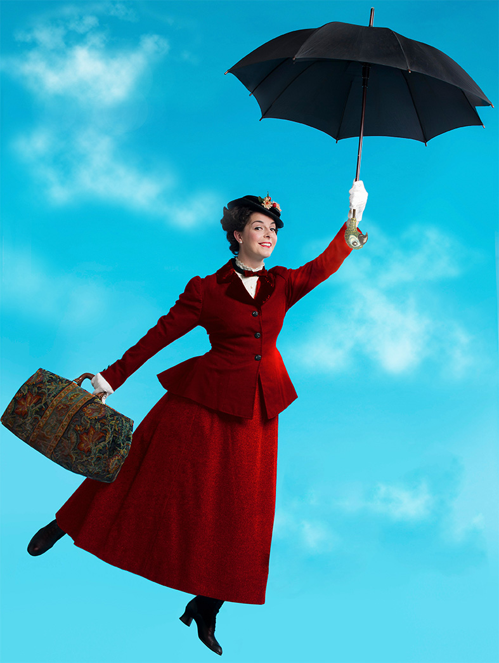
Mary Poppins quotes:

- In every job that’s done, there’s an element of fun.
- Come feed the little birds, show them you care, and you’ll be glad if you do.
- I make it a point never to give references. A very old-fashioned idea, to my mind.
- I would like to make one thing quite clear… I never explain anything.
- Never judge things by their appearance… even carpetbags. I’m sure I never do.
In your groups:
Read the quotes and, if necessary, do additional research on your character. You’ll have 15 minutes to craft a single presentation making the case for this character to be inducted into the Fictional Characters Hall of Fame.

Your presentation:
You will have 90 seconds to present to the audience. In those 90 seconds, you should summarize, quote, and paraphrase your character and any other research you’ve done. Make sure that as you do so, you are respectful of the character and audience. Only one member of the group needs to speak.

